**PRACTICAL:04**

**OBJECTIVE: RMI CALLBACK**

**TASK:01 Develop the RMI Callback application of Payroll and PayrollMessage services for calculating the earnings.**

**Remote Object-1:**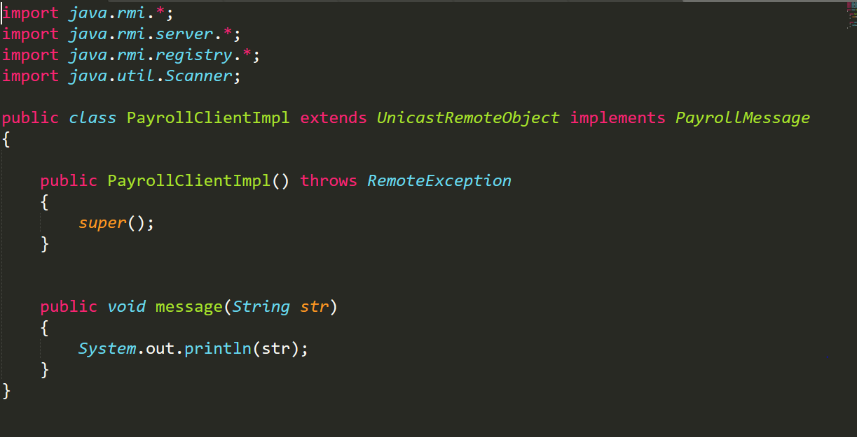

**Remote Object-2:**

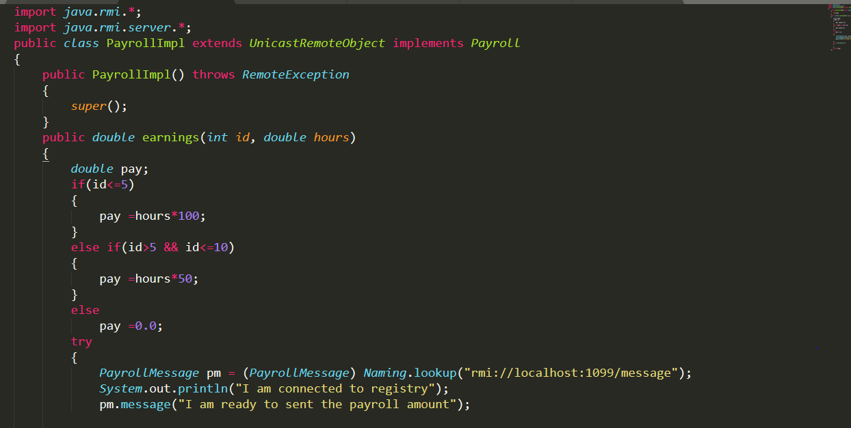

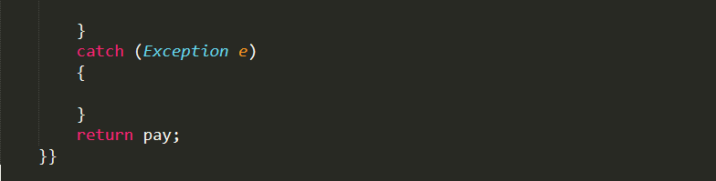

**Payroll-Message Interface:**

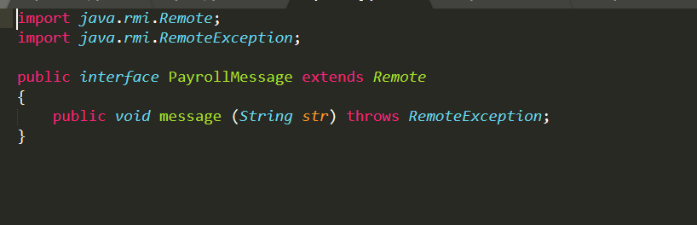

**Server:**

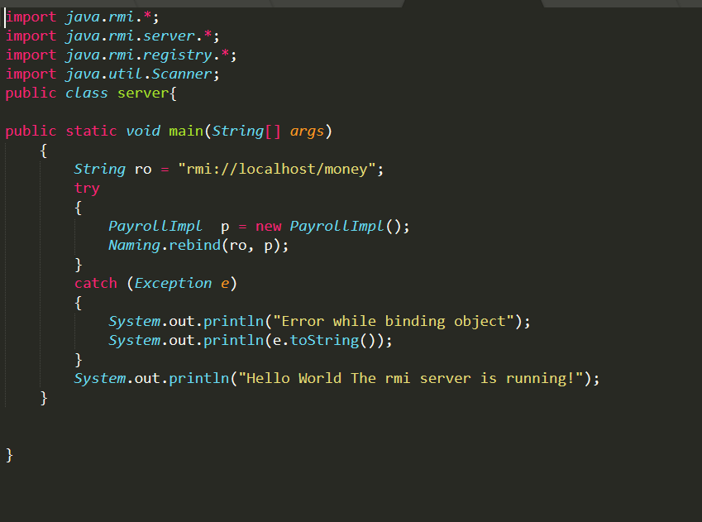

**Client:**

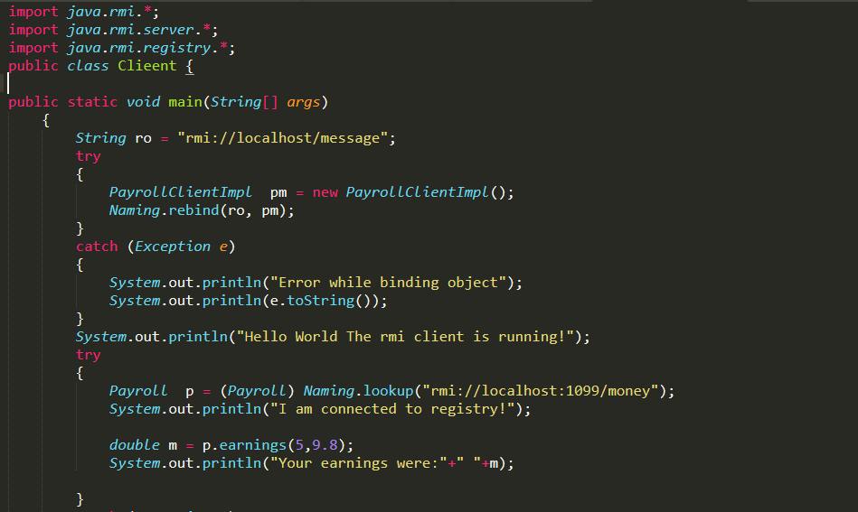

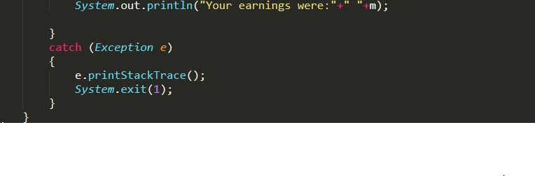

**Payroll Interface**

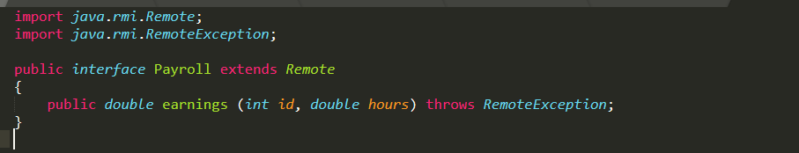

**Output:**

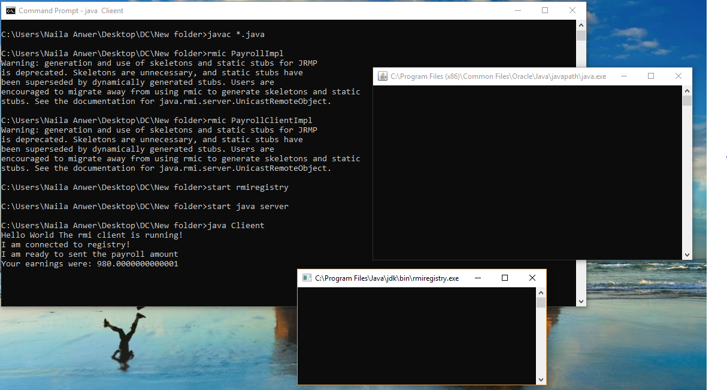

**Task-2: Optional Task: Develop an RMI application for chatting between client and server , the chatting should stop when both of them say “bye”.**

**Client:**

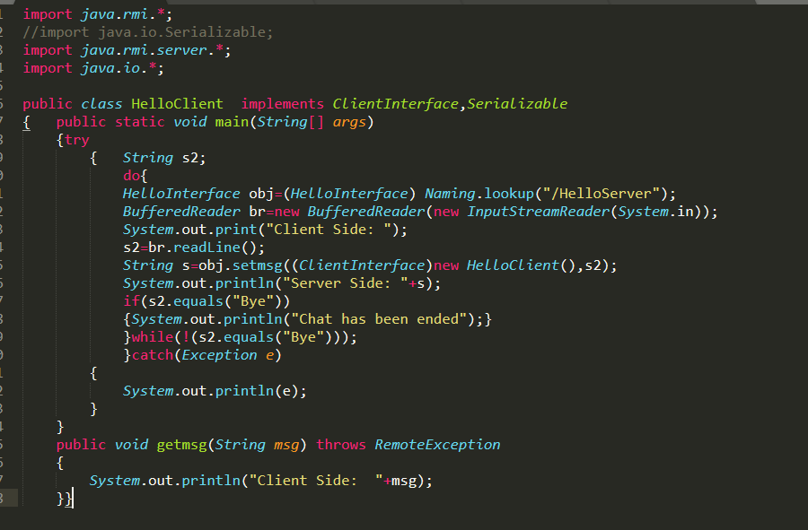

**Remote Object:**

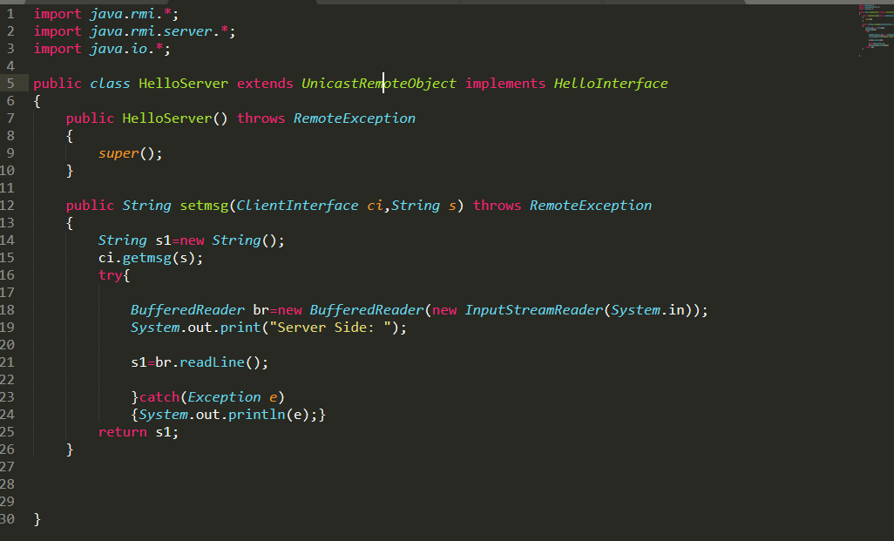

**Client Interface:**

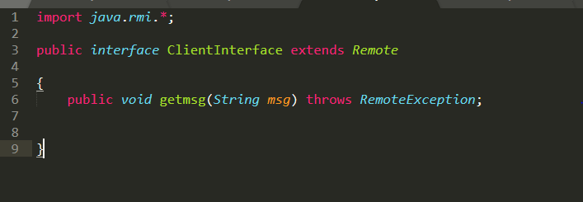

**Hello Interface:**

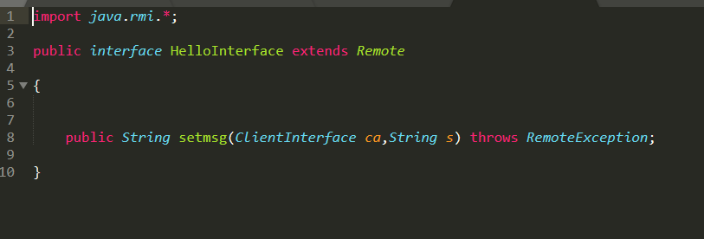

**Server:**

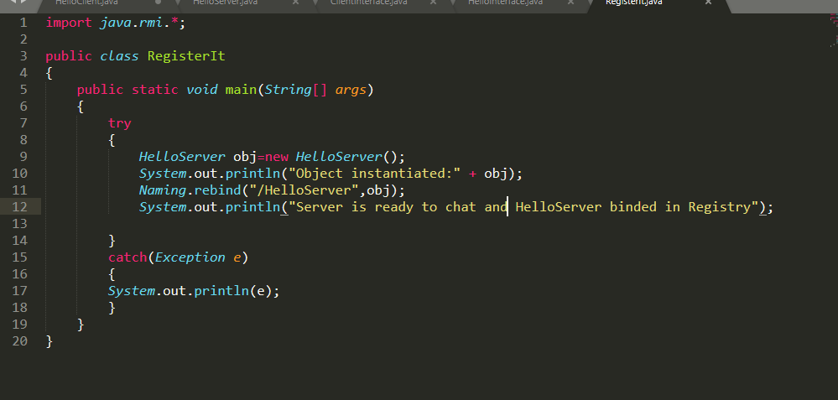

**Output:**

